JS Apps Exam – Point Of Sale Single Page Application
You are assigned to implement a Web application (SPA) using HTML5, JavaScript, AJAX, REST and JSON with cloud-based backend (Kinvey). The app that keeps users (cashiers), product entires and receipts. Users can register, login, logout, access the main view where a receipt can be composed (add products with their qunatity and price and save the basket to the database), list of all receipts and a receipt details view.
You are allowed to use libraries like jQuery, Handlebars and Sammy. Frameworks and libraries like React, Angular, Vue are not permitted!

Create a Kinvey REST Service
Register at Kinvey.com and create an application to keep your data in the cloud.
Create a collection entries. Each product has type, qty, price and receiptId.
Create a collection receipts. Each receipt has an active property, initially set to true, productCount and total.

Test the Kinvey REST Services

Common Responses
Note: When creating or updating records, the response will contain the entire record body, as it appears in the database. It’s advisable if you observe network traffic via Postman or using your browser’s dev-tools, to view details about each request.
Response Code | Response Body
200 OK | <Record data>
201 Created | <Record data>
204 No Content | <Empty>
401 Unauthorized | {  "error": "InvalidCredentials",  "description": "Invalid credentials. …",  "debug": ""  }
404 Not Found | {  "error": "EntityNotFound",  "description": "This entity not found in the collection",  "debug": ""  }
Error response  409 Conflict | {  "error": "UserAlreadyExists",  "description": "This username is already taken. …",  "debug": ""  }

Using Postman or other HTTP client tool (you can use Kinvey’s built-in API Console), test the REST service endpoints:

User Registration (Sign Up)
POST https://baas.kinvey.com/user/app_key/
Request headers | Authorization: Basic base64(app_id:app_secret)  Content-Type: application/json
Request body | {  "username": "testuser",  "password": "testuserpass890"  }
The request needs “Basic” authentication. Use the Kinvey App Key and Kinvey App Secret as credentials.
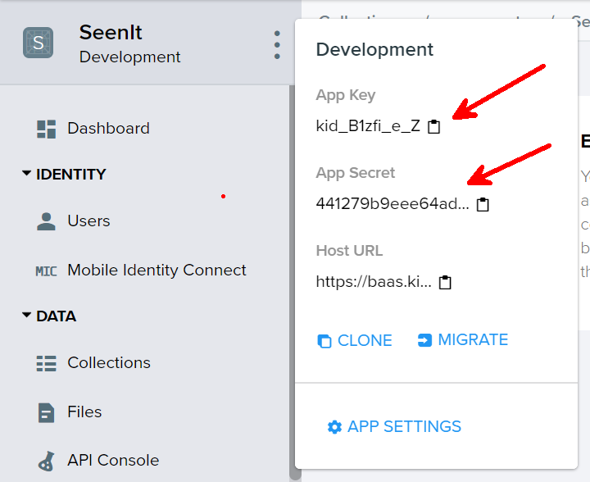

User Login
POST https://baas.kinvey.com/user/app_key/login
Request headers | Authorization: Basic base64(app_id:app_secret)  Content-Type: application/json
Request body | {  "username": "testuser",  "password": "testuserpass890"  }
Successful login returns an “authtoken” which is later used to authenticate the CRUD operations.

User Logout
POST https://baas.kinvey.com/user/app_key/_logout
Request headers | Authorization: Kinvey authtoken
To logout, you need to provide the “authtoken” given by login / register as “Kinvey” authorization header.

Get Active Receipt
GET https://baas.kinvey.com/appdata/app_key/receipts?query={"_acl.creator":"userId","active":"true"}
Request headers | Authorization: Kinvey authtoken
This will return the receipt that’s active for the currently logged in user. Use this to populate the Editor, or if it’s not found – create a new receipt and set it to be active.

Get Entries by Receipt ID
GET https://baas.kinvey.com/appdata/app_key/entries?query={"receiptId":"receiptId"}
Request headers | Authorization: Kinvey authtoken
You may use this query to get all entries of the currently active receipt, or entries for receipt details.

Create Receipt
POST https://baas.kinvey.com/appdata/app_key/receipts
Request headers | Authorization: Kinvey authtoken  Content-Type: application/json
Request body | {  "active": true,  "productCount": 0,  "total": 0  }

Add Entry
POST https://baas.kinvey.com/appdata/app_key/entries
Request headers | Authorization: Kinvey authtoken  Content-Type: application/json
Request body | {  "type": "Apple",  "qty": 5,  "price": 0.3,  "receiptId": "59affdae3044bb86044a79bd"  }
New entries should always be added to the active receipt.

Delete Entry
DELETE https://baas.kinvey.com/appdata/app_key/entries/entry_id
Request headers | Authorization: Kinvey authtoken

Get My Receipts
GET https://baas.kinvey.com/appdata/app_key/receipts?query={"_acl.creator":"userId","active":"false"}
Request headers | Authorization: Kinvey authtoken
Use the ID of the currently logged in user. The user should see only his or her receipts on the overview screen.

Receipt Details
GET https://baas.kinvey.com/appdata/app_key/receipts/receipt_id
Request headers | Authorization: Kinvey authtoken

Commit Receipt
PUT https://baas.kinvey.com/appdata/app_key/receipts/receipt_id
Request headers | Authorization: Kinvey authtoken  Content-Type: application/json
Request body | {  "active": false,  "productCount": 0, // Sum of all products  "total": 0, // Total cost of all products  // Other receipt properties  }
To mark a receipt as finalized (client has checked out), simply update it to set its active property to false. You need to send the whole receipt object, so don’t forget to fetch the receipt from the database first.

HTML and CSS
You аre given the Web design of the application as HTML + CSS files.
- Initially all views and forms are shown by the HTML. Your application may hide by CSS (display: none) or delete from the DOM all unneeded elements or just display the views it needs to display.
- You may render the views / forms / components with jQuery or Handlebars.
Important: don’t change the elements’ class name and id. Don’t rename form fields / link names / ids. You are allowed to add data attributes to any elements. You may modify href attributes of links and add action/method attributes to forms, to allow the use of a routing library.
Including the <section> elements is required for the style to display correctly!

Client-Side Web Application
Design and implement a client-side front-end app (SPA). Implement the functionality described below.

Notifications (10 pts)
The application should notify the users about the result of their actions.
- In case of successful action an informational (green) notification message should be shown, which disappears automatically after 3 seconds or manually when the user clicks it.
- In case of error, an error notification message (red) should be shown which disappears on user click.
- During the AJAX calls a loading notification message (blue) should be shown. It should disappear automatically as soon as the AJAX call is completed.
Points for notifications are awarded separately for each section.

Navigation System (10 pts)
Implement a navigation system for the app: navigation links should correctly change the current screen (view).
- Clicking on the links in the menu or individual links should display the view behind the link (views are sections in the HTML code).
- The given „Navigation“ menu should be visible only for logged in users. Anonymous users can only view the sign in/register section.

Register User Screen (5 pts)
By given username, password and repeat password the app should register a new user in the system.
- After a successful registration, a notification message “User registration successful.” should be displayed and the user should be redirected to the home view.
- You need to validate the input. A username should be a string with at least 5 characters long. Passwords input fields shouldn’t be empty. Both passwords should match.
- In case of error (eg. invalid username/password), an appropriate error message should be displayed and the user should be able to try to register again.
- Keep the user session data in the browser’s session storage.
- Clear all input fields after successful register.
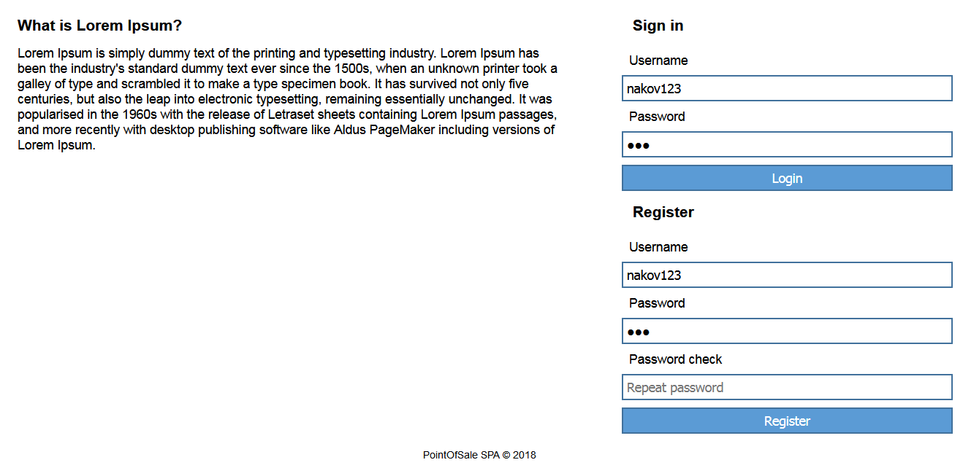

Login User Screen (5 pts)
By given username and password the app should be able to login an existing user.
- After a successful login, a notification message “Login successful.” should be displayed and and the user should be redirected to the home view.
- In case of error, an appropriate error message should be displayed and the user should be able to fill the login form again.
- Form validation should be the same as register.
- Keep the user session data in the browser’s session storage.
- Clear all input fields after successful login.

Logout (5 pts)
Successfully logged in user should be able to logout from the app.
- After a successful logout, a notification message “Logout successful.” should be displayed.
- After successful logout, the Sign In screen should be shown.
- The “logout” REST service at the back-end should be obligatory called at logout.
- All local information in the browser (user session data) about the current user should be deleted.

Home Screen (Receipt Editor) (45 pts)

Display Currently Active Receipt (15 pts)
Whenever the user opens the editor, you should retrieve the currently active receipt and all products related to it (by receiptId). If there is no active receipt, you must create it in the database. Note that the HTML contains hidden input fields, which you can use. There must be only one active receipt at any one time on the server!
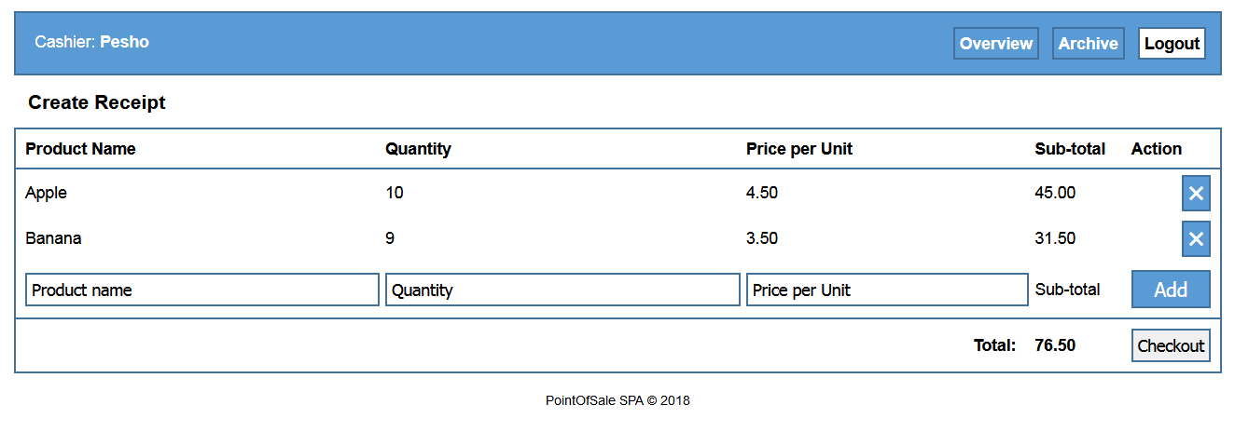

Add New Entry (10pts)
Clicking on Add creates a new entry, using the receipt ID of the currently active receipt and the data from the input fields. The fields must be validated:
- Product name must be a non-empty string
- Quantity must be a number
- Price must be a number
Update the value of Sub-total and Total in real time, whenever the user changes Quantity or Price to a valid value. Upon successfully adding the entry to the database
After successful entry creation, display a notification “Entry added”, add the information to the end of the list of entries and clear all input values.

Update Sub-total and Total (5 pts)
When the user enters a valid value for Quantity and Price per Unit, the displayed values for Sub-total for the new entry and Total for the receipt should be updated.

Remove Entry (5 pts)
Clicking the delete button next to each entry must remove it from the database and delete the row from the table. After successful deletion, update the value of Total. Display a notification “Entry removed” and remove the corresponding elements from the list of entries.

Checkout Receipt (10 pts)
Clicking on Checkout should perform the following:
- Display a notification “Receipt checked out”
- Update the receipt in the database to have its active property set to false and the properties productCount and total populated with the correct values
- Prepare the editor for a new receipt by creating it in the database and clearing the screen of any old information.
Before carrying out any actions, make sure the receipt contains at least one entry – the user should not be able to checkout an empty receipt!

All Receipts (10 pts)
Display a list of all receipts that the user has created. Use the stored user ID to retrieve only the relevant records. Every receipt must have a link that leads to its details. The user should see only his or her receipts.
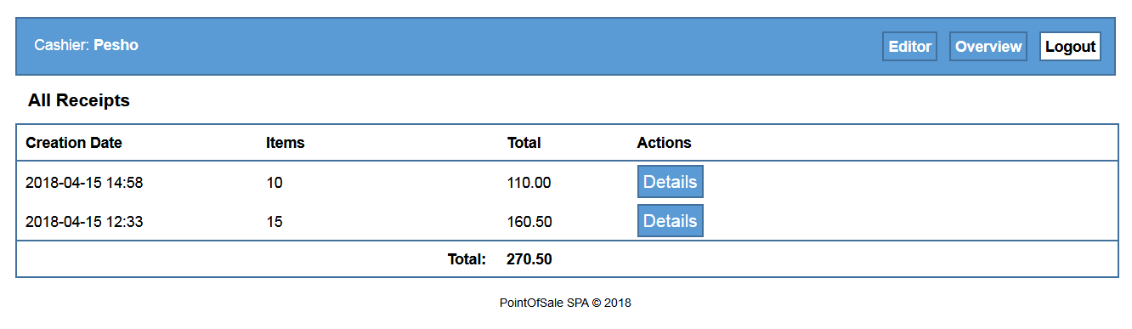

Receipt Details (10 pts)
Display the selected receipt with a list of all entries in it. Use the receipt ID to filter only the related entries.
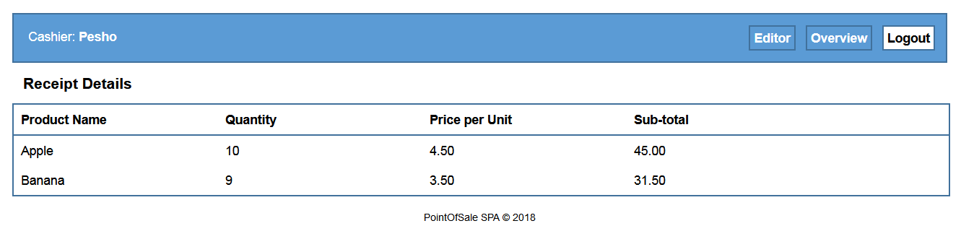

Subtmitting Your Solution
Place in a ZIP file your project folder. Exclude the node_modules folder. Upload the archive to the Judge.

